**Technical Analysis of Hindustan Unilever Using Moving Averages and Oscillators**

*-Debrupa Mukherjee*

**Considering the daily stock price data of Hindustan Unilever from 1st January 2020- 15th October 2024.**

**Objective:** To identify and interpret **short-term buy and sell signals** using the Golden Cross / Death Cross, Ultimate Oscillator, and Stochastic Oscillator and observe their alignment with actual price trends.

**Lagging Indicator:** Considering 50 Days and 100 Days Moving Average as a Short-term and Long-term MA respectively.

Since we are performing our analysis in retrospect, this indicator has less predictive power.

**Golden Cross and Dead Cross**

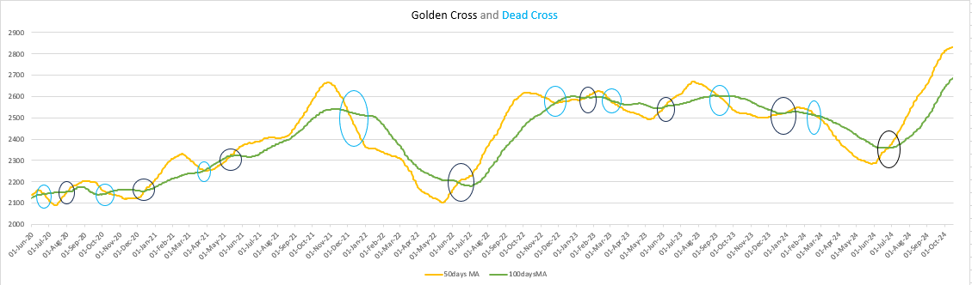

The **black** circles depict the **Golden Cross:** When the 50-day Moving Average (MA) crosses above the 100-day MA from below and continues to rise, it signals the beginning of a **potential bullish trend**. For short-term investors, this is often interpreted as a **buying signal**.

The **blue** circles depict the **Dead Cross:** The 50-day Moving Average crossing below the 100-day MA from above suggests a **potential bearish trend**, often viewed as a **selling signal** by short-term investors.

**Leading Indicators: Ultimate Oscillator(UO)**

A **momentum oscillator** designed to capture momentum across three different timeframes—short, medium, and long—typically using periods of 7, 14, and 28 days.

**Construction:** At first the 7,14 and 28 days rolling averages were constructed. Then, the weighted average is calculated giving weights 4,2,1 to short, medium and long term respectively.

When the value of UO rises **above 70**, then the stock price is expected to fall immediately. Thus, it is a **Selling Signal**.

When the value of Ultimate Oscillator falls **below 30**, then the stock price is expected to rise, thus it is **Buying Signal** for an investor.

So, UO can be used as a leading indicator, to form an idea about whether the stock prices are expected to rise or fall in the immediate future.

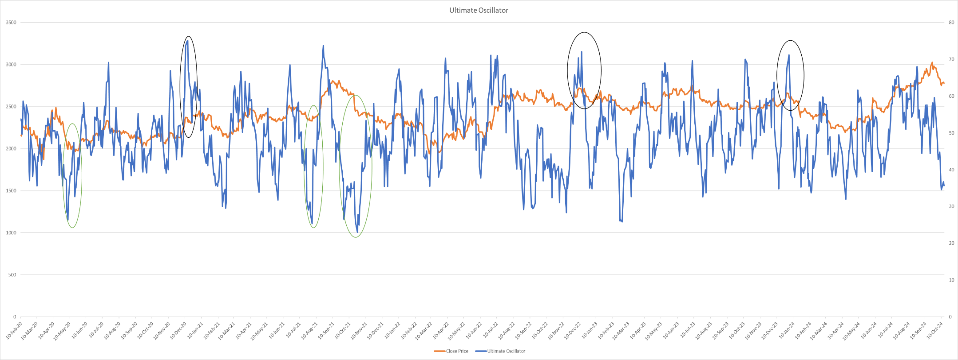

Here, the black circles mark, UO>70, and has witnessed an immediate price fall after reaching that mark. Again, the green circles mark UO<30, and has witnessed an immediate rise in stock prices,

**Leading Indicators: Stochastic Oscillator (SO)**

A **momentum indicator** that compares a stock’s closing price to its price range over a specific period. Here, we have used a 7-day window.

The value of SO ranges between 0 to 100. When it is **approaching 100**, it is a **Selling Signal**, and when **approaching 0**, it is a **Buying Signal.**

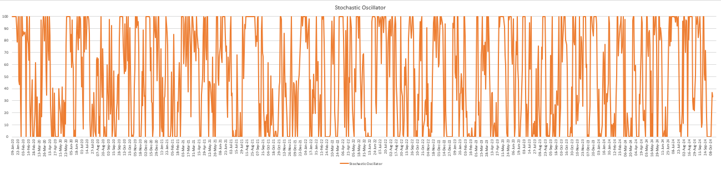

**Investor Takeaway:**

The study found that Golden Crosses aligned with major upward trends, while Death Crosses indicated short-term corrections. The Ultimate Oscillator effectively highlighted overbought and oversold zones before price reversals, and the Stochastic Oscillator provided quick momentum cues. Combined, these indicators improved signal accuracy, showcasing analytical precision.